4Qs AD- 07.08.2019; Wednesday- Class I
1. If one RULER measures 5 centimetres; how many will two scales measure if both are placed together in a horizontal line? ____________
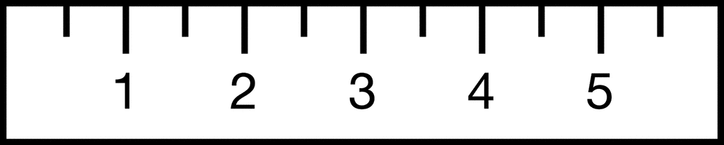.
2. How many circles are there in this figure?
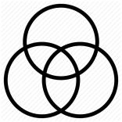

3. Three (3) birds were sitting on a wall. One (1) flew away. After some time five (5) birds came and sat on the wall. How many birds in all now?
_________
4. Six (6) girls how many earrings?
**********************************************

4Qs AD- 07.08.2019; Wednesday- Class II
1. Supply the missing numbers
- 10, 9, _______, ________, 6

- 12, 14, 16, ______, ________.

2. Find and write the missing numerals
- 50, 60, _______, ________, 90

- 5, _____, 15, ______, 25.

3. How much money in all?
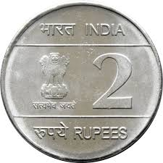 = Rs. _______
16. Match the following
A B
a.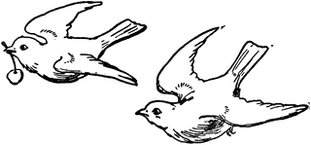 i. A family of five
b .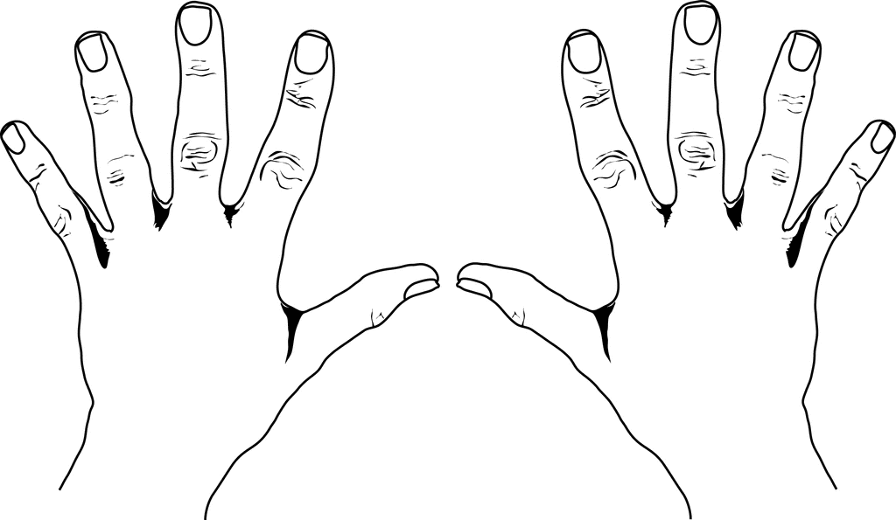 ii. One moon and many stars
c. 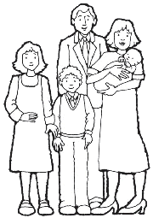 iii. A pair of birds
d. 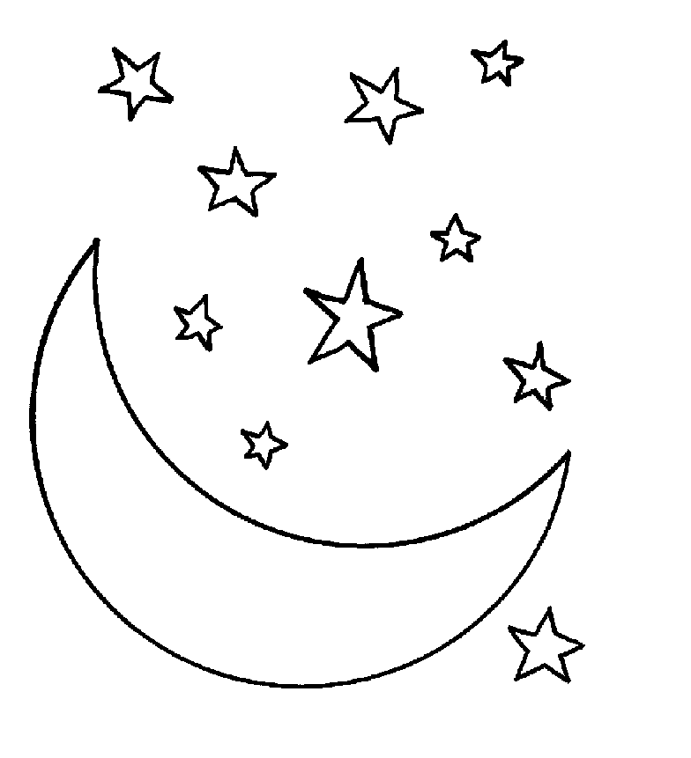 iv. Ten fingers in two hands
****************************************************
4Qs AD- 07.08.2019; Wednesday- Class III
1. Complete the following series:
i. 211, _______, _______, 214, _________, ________, 217
ii. 7, 14, _______, _______, _______, _______, 49
2. i. How many 500 Rs-notes in Rs. 10, 500?
a. 500 ( ) b. 1000 ( ) c. 201 ( ) d. 21 ( )
ii. Fill in the missing Place Values
a. Ones, _______, Hundreds, ______ , _______, Lakhs, ________
3. Answer the following:
i. January 2019, February 2019 and March 2019 how many days in all? ___
ii. How many minutes in an hour? ____________
4 i. If a toy costs Rs 25 and a teddy bear costs Rs 57? Which is costlier and by how much? _____________________
ii. Arrange in a descending order 739, 379, 973, 937, 793, 397
___________________________________________

****************************************************

4Qs AD- 07.08.2019; Wednesday- Class IV
1. Which is the largest possible 4 digit number among the following?
a.8652 [ ] b. 8562 [ ]
c. 9652 [ ] d. 9562 [ ]
2. Look at the word: MONALISA. Which are the letters that have straight vertical lines?
a. O & S [ ] b. A & N [ ]
c. M, N, L & I [ ] d. Only I [ ]
3. How many ¹/₅^{ths} (one-fifths) will make 2 wholes?
a. 2 [ ] b. 1 [ ] c. 10 [ ] d. 5 [ ]
4. What is the time at midnight 12 0’clock?
a. 12:00 hours [ ] b. 14:00 hours [ ]
c. 24:00 hours [ ] d. 00.00 hours [ ]

***************************************************

4Qs AD- 07.08.2019; Wednesday- Class V
1. Which among the following Roman numerals is correctly recorded??
a. 25- XVX [ ] b. 19- XIX [ ]
c. 32- XXVVII [ ] d. 15-VVV [ ]
2. How many 8’s are there in the product of 24 and 479
a. 479 x 8 [ ] b. 1619 [ ]
c. 24 x 6 [ ] d. 1437 [ ]
3. My mother started reading a book on Monday. She read 5 pages every day EXCEPT on Saturday and Sunday? If the book has 35 pages, on which day did my mother finish reading the book?
a. Wednesday [ ] b. Thursday[ ]
c. Tuesday [ ] d. Friday [ ]
4. Complete the series:
i. 10015, 9815, 9615, __________, _________
ii. 12, 48, 13, 52, 14 ______, 15, ________
*********************************************

4Qs AD- 07.08.2019; Wednesday- Class VI
1. Find the successor of the smallest 5 digit number?
a. 100000 [ ] b. 10001 [ ] c. 99999 [ ] d. 111111 [ ]
2. Madan made 17 sandwiches for his friends. If Madan had 4 more sandwiches, he would have made exactly thrice as many sandwiches as Karan. How many sandwiches did Karan make?
a. 7 [ ] b. 21[ ] c. 24[ ] d.3: 14[ ]
3. Observe the given numbers:
2, 11, 13, 4, 12, 17, 22, 16, 23, 25, 21.
If M is the sum of all PRIME NUMBERS and N is the sum of all the COMPOSITE NUMBERS in the given list, what is the difference between M and N

a. 28 [ ] b. 34 [ ] c. 44[ ] d. 36 [ ]

4. What is the cost of 30.5 litres of milk at the rate of Rs.7.50 per litre?
a. Rs 225.75 [ ] b. Rs. 223.75 [ ]
c. Rs. 228.75 [ ] d. Rs. 232.75 [ ]
**********************************************************

4Qs AD- 07.08.2019; Wednesday- Class VII
1. Which of these is same as 0.27?
a. ^{2.7} / ₁₀ [ ] b. ^{2.7} / ₁₀₀ [ ] c. ²⁷ / ₁₀ [ ] d. ²⁷/₁₀₀₀ [ ]

2. Which of these fractions is the largest?
{ ⁴⁹ / ₁₂, ³⁷ / ₆, ⁷ / ₂, ¹⁶ / ₃ }
a.⁴⁹ / ₁₂[ ]b. ³⁷ / ₆ [ ] c.⁷ / ₂ [ ] d.¹⁶ / ₃[ ]

3. What fraction of shapes in the collection below are triangles?

a.½ [ ] b. ²/₅ [ ] c. ⁴/₅ [ ] d. ²/₃ [ ]

4. If this is a solid cylinder and is cut into two halves along the vertical line. What will be the resultant shape of the two circular faces of the cylinder?
a. Rectangular b. Circular
c. Semi-circular d. ¹/₄th of acircle

**********************************************************

4Qs AD- 07.08.2019; Wednesday- Class VIII
1. Which among the following is not a polygon?
a. Circle [ ] b. Trapezium [ ]
c. Rhombus [ ] d. Octagon [ ]

2. Which of the following is equal to 2a- (a-2b)?
a. a-2b [ ] b. a + 2b[ ]
c. 3a - 2b [ ] d. 3a + 2b [ ]

3.“Almost one and half million Indians fought in the First World War” Which of these could be the number of Indians who fought as per the aforesaid statement?
a. 1.2 lakhs [ ] b. 1.4 lakhs [ ]
c. 12.5 lakhs [ ] d. 14.lakhs [ ]

4. (a²)³ can be represented as ________________
a. a² x 3 [ ] b. a² x a³ [ ]
c. a² x a²x a² [ ] d. a²+ a²+ a² [ ]
**********************************************************

4Qs AD- 07.08.2019; Wednesday- Class IX
1. If A is substituted by 4, B by 3, C by 2, D by 4, E by 3, F by 2 and so on, then what will be total of the numerical values of the letters of the word SICK?

a. 11 [ ] b 12 [ ] c. 10 [ ] d. 9 [ ]

2. If A = 26, B= 25, C= 24, D= 23………………………. Z = 1 then find the sum of all the 26 alphabets.
a. 351 [ ] b. 500 [ ]
c. 356 [ ] d. 298 [ ]

3. What is the sum of the numbers on the opposite faces of a ludo- game dice?
a. 10 ( ) b. 12 ( )
c. 7 ( ) d. 15 ( )

14. A man invested Rs.10,000/- in a bank for 5 years @ 7.5% Simple Interest. What amount money is he expected to get back after the stipulated period of investment?
a. Rs. 10375 ( ) b. Rs. 10573 ( )
c. Rs. 10735 ( ) d. Rs. 10000 ( )
*********************************************************

4Qs AD- 07.08.2019; Wednesday- Class X
1. If you write down all the numbers from 1 to 100, then how many times do you write 3 [three]?
a. 11 [ ] b. 18 [ ] c. 20 [ ] d. 21 [ ]

2. A tailor had a number of shirt pieces to cut from a roll of fabric. He cut each roll of equal length into 10 pieces. He cut at the rate of 45 cuts a minute. How many rolls would be cut in 24 minutes?

a. 32 rolls [ ] b. 54 rolls [ ] c. 108 rolls [ ] d. 120 rolls [ ]
3.Today is Varun's birthday. One year, from today he will be twice as old as he was 12 years ago. How old is Varun today?

a. 20 years [ ] b. 22 years [ ] c. 25 years [ ] d. 27 years [ ]

4. Ayush was born two years after his father's marriage. His mother is five years younger than his father but 20 years older than Ayush who is 10 years old. At what age did the father get married?

a. 23 years [ ] b 25 years [ ] c. 33 years [ ] d. 35 years [ ]
**********************************************************

4Qs AD- 07.08.2019; Wednesday- Class XI
1. A passage 12 m long, 3 m high and 4 m wide has two doors of 2.5 by 1.5 m and a window of 2 m by 0.6 m. The cost of colouringth walls and ceiling at Rs. 15 per sq. m is?
i. Rs. 1023 [ ] ii. Rs. 432 [ ]
iii. Rs. 2029.5 [ ] iv Rs. 1635 [ ]

2. The surface areas of the three continuous faces of a cuboid are 6, 15 and 10 su. Cm respectively. The volume of the cuboid is

i. 30 c.c.[ ] ii. 20 c.c. [ ] iii. 40 c.c[ ] iv. 35 cc. [ ]

3. Which among the following is not a perfect square?
i. 15625 [ ] ii. 4884 [ ] iii. 325 [ ] iv. 360000 [ ]

4. Supply the missing numeral in the series
144, 169, _______, ________256, 289, _________, 361.

**********************************************

4Qs AD- 07.08.2019; Wednesday- Class XII
1. Draw a cube and label the points
A, B, C, D, E, F, G& H
i. What are AB, BC, CD & AD of the cube? ________
ii. What are the points A, B, C, D, E, F, G & H called? ______
2. Name the faces of the cube. ______________________________________________
3. Complete the following algebraic expressions
i. (x + y )² = _____________________________
ii. (x + y ) (x -y ) = ________________________
4. Which among the following is known as Hardy-Ramanujan number?
i. 1729 [ ] ii. 9271 [ ]
iii. 1279 [ ] iv. 7291 [ ]
********************************************

